CLOSE TO HOME: HOUSING FIRST PLAN IMPLEMENTATION
Cowichan Housing Association
Progress Report
March 31, 2018
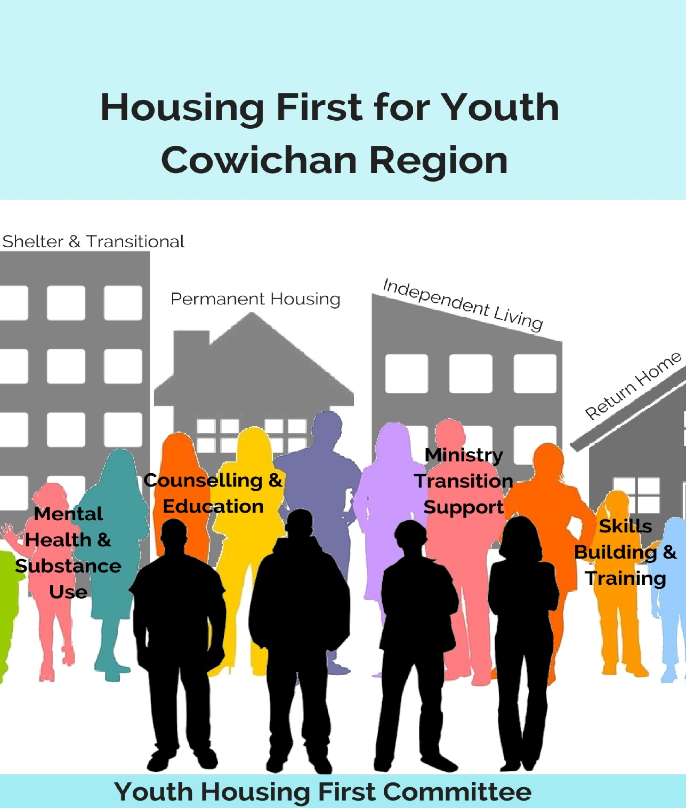

Consultations and research in the Cowichan Region have identified the need for developing a spectrum of housing for youth, and a system of care that supports young people to access and maintain housing, as well as to move forward in life. Key to this model is the understanding of the geographic and demographic diversity of the Cowichan Region. Our model articulates a multidimensional lens through which youth homelessness and housing needs to be approached.

The Close to Home Housing First Plan for Youth lays out two key objectives in this regard, and work is being undertaken to develop projects and partnerships to achieve these aims. This report outlines progress on projects and partnerships that have been identified and/or are underway regarding implementation of the Youth Housing First Plan.

Objectives and Partnerships To Date | Lead and Projected Timeline
Objective I: Shelter, Transitional and Permanent Housing that meets the needs of all youth

- Prevention: Upstream Project: Upstream Projects focus on helping young people at risk of homelessness through partnering with schools to identify and provide supports to youth and their families as a means to prevent homelessness. Potential lead: Social Planning Cowichan. | Social Planning Cowichan:  2019
- Youth Host Homes Pilot Project: Social Planning Cowichan will host a project to develop a Youth Host Homes Program. Host Homes are a form of respite accommodation to provide young people with emergency supports as an alternative to the shelter system. Host Homes Programs are considered to be safe, high quality accommodation for a short period of time to give youth and their families a ‘breather’, and provide a supportive environment for all parties to rebuild their emotional resilience and renegotiate relationships. Work is underway to conduct fundraising for this project; anticipated start date is 2018. | Social Planning Cowichan  2018
- Youth Home (13-18): Cowichan Valley Open Learning Cooperative (CVOLC) Leadership Class are leading the development of a youth home concept to support youth aged 13-18 in need of emergency assistance and support. CVOLC Students have produced a video illustrating the issue of hidden homelessness among young people in the Cowichan Region. https://www.youtube.com/watch?v=4u2rIYlk9gg&feature=youtu.be  The project is currently exploring two potential sites and developing a business plan in partnership with CMHA, Social Planning Cowichan and CHA. | CVOLC, Canadian Mental Health Association, Social Planning Cowichan:  2018
- Youth Transitional Housing: CMHA currently serves a small number of youth aged 19 - 24 in transitional housing and is actively looking to expand those services to include youth under the age of 19. Currently some of the youth they serve are under Youth Agreements and many of these youth go into existing transitional housing or go directly into scattered site housing depending on the need. CMHA is interested in expanding their capacity and is exploring housing site options to accommodate youth transitional housing. A current opportunity to house young mothers with children is in exploration. | Canadian Mental Health Association:  2018 and beyond
- Scattered Site Housing: CMHA subleases units in the region and acts as a liaison between individuals and landlord as well as providing support services to individuals. CMHA is interested in expanding their capacity to provide scattered site housing to accommodate youth. They have a small number of youth aged 19 - 24 in scattered site housing and develop a Moving Forward Plan with each individual. Where appropriate this plan helps youth transition to a position where they have direct relationships with landlords. This can allow CMHA to move away from a liaison role to one of providing external support where necessary. | Canadian Mental Health Association:  2018 and beyond
Objective II. A System of Care that provides for the range of supports needed to ensure youth are appropriately sheltered or housed and that youth well-being is central

- Partnership Building
The following agencies have indicated their willingness to partner in Housing First programming to provide the necessary supportive services.

Support Services: Skills Building and Training
- Canadian Mental Health Association- Cowichan Valley Branch
- Cowichan Independent Living
- Cowichan Intercultural Society
- Cowichan Women Against Violence
- Cowichan Valley Youth Services (formerly COS)
- Global Vocational
- Hiiye'yu Lelum, House of Friendship

Support Services: Mental Health and Substance Use
- Canadian Mental Health Association- Cowichan Valley Branch
- Discovery Youth and Family Services
- Duncan Mental Health
- Margaret Moss

Support Services: Counselling and Education Supports
- Canadian Mental Health Association- Cowichan Valley Branch
- Cowichan Family Life Association
- Cowichan Women Against Violence
- Cowichan Valley Youth Services (formerly COS)
- Discovery Youth and Family Services
- Hiiye'yu Lelum, House of Friendship
- Kw’umut Lelum Child and Family Services
- Literacy Now Cowichan

Support Services: Support to Transition out of Care
- Kw’umut Lelum Child and Family Services

